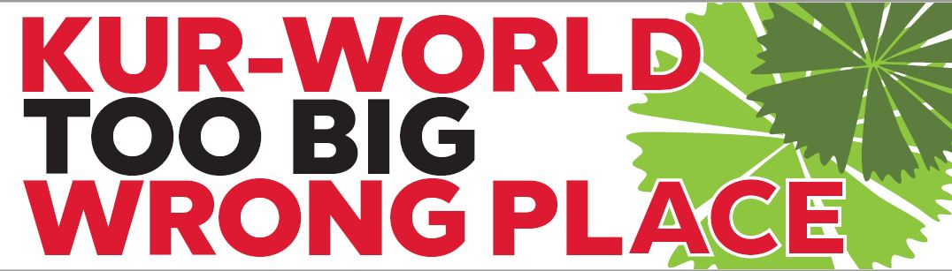
KUR-WORLD proposal for Kuranda

WHAT IS IT?
Equestrian Centre and Farm Theme Park | 110 beds farm stay  15 glamping tents
‘Queenslander Lots’ | 21 residential lots,  $600,000 / lot*
‘Premium Villas’ | 288 residential lots  approx. $592,000 / lot*
‘Lifestyle Villas’ | 56 residential lots, approx. $600,000 /lot*
Business and Leisure Hotel and Function Centre 4-star | 270 apartment rooms, approx. $392,000 / apartment*
Student accommodation | 330 beds
Wellbeing Retreat | 60 suites
Five Star ‘Eco-Resort’ | 200 rooms
‘Rainforest Education Centre and Adventure Park’ | 350 beds  10 glamping tents  Zip line(s)
‘KUR-Village’ | Plaza, shops, restaurants, offices, amphitheatre
Golf Course | 12 hole with club house and function centre

Huge high density housing development / theme park marketed
as an ‘eco-resort’
‘AQUIS in the rainforest’

TOO BIG
4000 people plus 635 private residences
15+ buildings 5 storeys high
WRONG PLACE
cuts narrow ecological corridor linking
North and South Wet Tropics World Heritage. Internationally recognised Key Biodiversity area

NOT ENOUGH WATER
TOO MUCH WASTE
Intends to use substantial unregulated groundwater
Waste water threatens water quality for residents and threatened species
ROAD CONGESTION
Kuranda Range road already close to capacity
Highways south of Cairns and Tablelands impacted

NO TRUST
No experience. Actions to date should be fined
Council facilitating development not balanced with protecting people of Kuranda or the environment

WE NEED YOUR HELP TO STOP THIS MONSTROSITY!
KUR-World EIS submissions open till 14 Jan ‘19
Write your own with templates at www.envirocare.org.au or www.kurandaregion.org/eis
Or direct at www.dsdmip.qld.gov.au/kur-world

